Multidisciplinary Senior Design Projects

GE 498

College of Engineering

Valparaiso University

Valparaiso, Indiana

Design Document

For the

Pellet 3D Printer

Date: 05-06-2024

|  |  |
| --- | --- |
| Prepared by: | Pellet 3D Printing (Vinyl Velociraptors) |
| Concurrence (Advisor): | Professor Luke |
| Concurrence (Advisor): | Professor El-Howayek |
| Approved (Customer): |  |
| Approved (Team Leader): |  |

Total Number of Pages: *15*

Executive Summary: This pellet printing modification is designed to be open source, available to hobbyists for purchase and install. The pellet printer is able to bypass the manufacturing costs associated with filament printing, use flexible materials normally unsuitable for filament printing, and allow users to mix pellets for their own blends of printed material.

Honor Code Statement

I have neither given or received, nor have I tolerated other’s use of unauthorized aid.

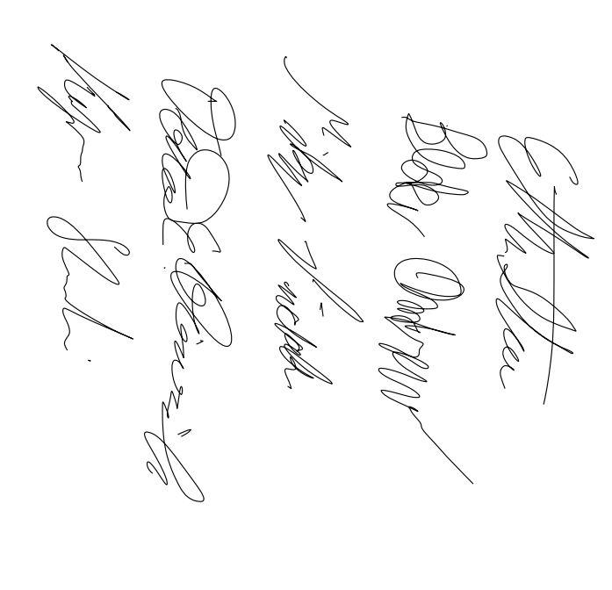

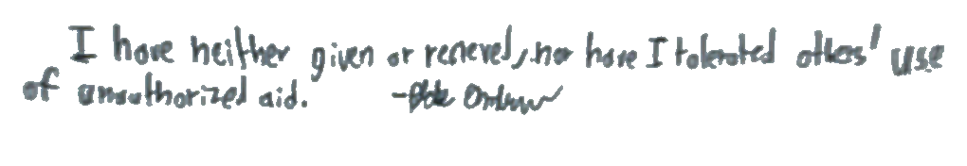

_________________________________________

Blake Andrew

_________________________________________

[Daniel Heinrich](mailto:daniel.heinrich@valpo.edu)

_________________________________________

[Mikey Pinchok](mailto:mikey.pinchok@valpo.edu)

_________________________________________

Kay Shoolian

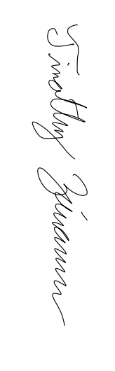

_________________________________________

Ethan Storer

_________________________________________

[Timothy Ziemann](mailto:timothy.ziemann@valpo.edu)

Table of Contents

**1 Introduction 4**

**2 System Description 4**

**2.1 Subsystem Description 4**

**3 Frequently Asked Questions (FAQ) 5**

**4 Design Problems and Solutions: 6**

Likely Problems while Assembling the Extruder 6

**5 Limitations and warnings 6**

Warnings: 7

Limitations: 7

**6 System Design Requirements 8**

Using An Ender-3 Requirement 8

Assembly Instructions Requirements 8

Time Study Requirements 8

Performance Check Requirements 8

Size Requirements 8

Accessibility Requirements 9

**6.2 Deviations from the System Design Requirements 9**

**7 Supporting Information 9**

7.1 Referenced Documents 10

7.2 Symbols and Abbreviations 10

**8 Distribution 10**

**Appendix A 11**

Part List and Budget: 11

**Appendix D, E, F 11**

Detailed drawings illustrating for all manufactured components 11

Assembly drawings: 13

Flow Charts for Control Systems 14

Computer Code: 14

Electrical circuits: 14

**Appendix G 15**

## 

## 1 Introduction

The goal of this project is to modify a stock Ender-3 3D printer to accept plastic pellets rather than filament and provide detailed documentation for hobbyists who want to replicate the design change.

## 2 System Description

Our system is a modified Ender 3 3D V1 printer. It is modified to utilize plastic pellets as a printing material instead of plastic filament. This modification would make the 3D print more environmentally friendly and cheaper with use of pellets over processed filament rolls. The other main goal is to make this project and modification open source. This will provide repeatable instructions for hobbyists to modify their printers at home through following an assembly guide with steps, parts, and a time study. This design report aims to walk through our problem definition, system overview, virtual prototype, and finalized budget. Our team (The Vinyl Velociraptors) have been working on these four categories for the last 10 months and this document will be a compilation of the data and product we have made.

## 2.1 Subsystem Description

The system begins with a hopper connected to the central mounting teapot via a corrugated tube. It is mounted atop the Ender 3 V2’s gantry.

The central mounting teapot houses the barrel, hotend, fans, extrusion screw, and the stepper motor that turns the extrusion screw. It is printed on the stock Ender 3 3D printer. This component also houses the barrel mounting system. There are two 3D printed barrel clamps which secure the barrel and allow for precise adjustment of it. These can be printed by the unmodified 3D printer. The part fan and barrel fan are also a part of this system and are crucial to keeping the system at the proper temperature.

The extrusion screw utilizes a logarithmic design to build pressure to push out plastic for printing. It is purchased from Xometry.

The barrel is a pipe that can be purchased from a hardware store. It is cut to size and press fit into the heater block using a vice.

The hot end contains the heat stock Ender 3 heat cartridge, chosen for its ease of implementation and compatibility with the existing Ender 3 heat cartridge and thermistor which are also utilized for our system. This heater block also contains a 0.6mm nozzle which can be purchased from Creality. The hotend and barrel subsystem is crucial for transforming pellets into molten material, ready for extrusion through the nozzle.

A extrusion screw bit, inserted into the hotend barrel, is driven by a stepper motor. This motor has a built in 5:1 gearbox and is connected to the extrusion screw bit through a coupler. The extrusion screw and geared stepper motor ensures a controlled and consistent feeding of pellets into the hotend barrel, contributing to the overall accuracy and reliability of the 3D printing process.

The system is seamlessly integrated with the Ender 3 V2's software, allowing users to control the pellet feeding process, temperature settings, and other parameters. Ender software integration ensures user-friendly control of the 3D printing process, making it accessible to experienced and novice users.

## 3 Frequently Asked Questions (FAQ)

Q: What is the estimated cost of making this printer modification?

A: Assuming you don’t have access to a machine shop, the total comes out to be around $200

Q: Where can I buy plastic pellets?

A: Pellets can be purchased in bulk from online stores like 3DxTech, we got our polypropylene (PP) pellets from [techkits.com](https://www.techkits.com/products/resin-ppnat/) because it was a much smaller quantity.

Q: How much does using pellets save compared to filament?

A: Pellets can be around 50% cheaper compared to filament. Depends on the quality of the filament and the size of the pellet order.

Q: Does this work with new versions of the Ender 3D printer?

A: Theoretically yes, although the mounting holes may be different. Nothing involved in the printing process is tied to the Ender-3 V1 specifically.

Q: How fast can this printer modification print?

A: We set it to print at 6.5mm/s for testing purposes, but likely could have printed faster. A lot of the speed limitations came down to the extra weight of the modified extruder.

Q: What slicer software did you use to make the custom settings for the pellet printer?

A: Prusa Slicer is our slicer of choice, but it is by no means the only option.

## 4 Design Problems and Solutions:

* Partially melted plastic pellets leaking through the o-ring at the interface of the “teapot” and the barrel
  + Solution was to improve the installation of the o-ring and install a new/better teapot. O-ring no longer acts as a thermal bridge
* Teapot would become partially melted the longer the printer remained hot.
  + O-ring was installed better and no longer acts as a thermal bridge
  + An additional fan was added to provide convection cooling to the top of the barrel
* Pressure created by screw during operation would deform the bracket
  + Bracket was replaced with a 3D printed teapot to provide improved rigidity.
* Screws that adjust the barrel position in the bracket do not provide adequate pressure to hold it in place.
  + Shallow blind holes can be drilled into the barrel to allow for better hold.

### Likely Problems while Assembling the Extruder

* Printer is beeping loudly
  + Thermistor is likely improperly installed or damaged. Inspect the thermistor and reseat it. If the printer continues to beep, ensure that none of the fans are blowing on it directly. If none of these fixes the beeping, consider replacing the thermistor. Also consider adding [Kapton Tape](https://www.amazon.com/ELEGOO-Polyimide-Temperature-Resistant-Multi-Sized/dp/B072Z92QZ2/ref=sr_1_3?dib=eyJ2IjoiMSJ9.h-JRr1e3E1CwxqoJ6uMO2BmJfaGTizoAiOb1eaALwjnH6LrruvnIAS14uhxhIEbOH6pV-1Fva2R6-EVIRDGD1e1mEPz9WMl7UcLoqDBCBAA6_KOeWEVoEXPQGM409fl1PovbMbLYf_2lg-RK-EyiGFjPZnBJuWajiiPRoR5yVF12GZQhfabGi-moWJ25_iMz17Oxdq3ra5CB8Pdw4aGZo-XMc0RpM4j_VlZ6SFi1tTE.bV4AVsmkrxIFiJamOGJ493YFOgfDgVTAkJg4Q29mxbI&dib_tag=se&hvadid=616931741728&hvdev=c&hvlocphy=9016213&hvnetw=g&hvqmt=e&hvrand=8057637807602373876&hvtargid=kwd-10054047&hydadcr=24664_13611849&keywords=kapton+tape&qid=1714871133&sr=8-3) around the heat block for improved installation. Another option to insulate the barrel if the Kapton Tape is not sufficient is the use of fiberglass insulation, like that from exhaust wrap.
* 3D prints are messy
  + Ensure you are using the provided print configurations.
* 3D prints won’t stick to the bed
  + Ensure your bed is hot enough for your choice of plastic.
  + Clean the bed using isopropyl alcohol to ensure there is no plastic residue.
  + If using Polypropylene, ensure that the bed is covered in packing tape, and that the bed heat is upwards of 80 degrees celsius.
* Packing tape is lifting off of the bed
  + While still printing, tape down the lifting sections with more packing tape

## 5 Limitations and warnings

* While using the teapot in either PETG or ABS materials, the teapot will melt if it is not set to the proper temperature and cooling levels.
  + If this becomes a constant issue, a teapot printed from a higher temperature glass transition point material such as Nylon 11 in an SLS printer can negate those problems
  + An insulative fiberglass board cut to add insulation below the teapot can reduce the heat transfer into the teapot.
    - Cheaply by hand and stencil with a pre purchased board
    - Using a laser cutting service such as sendcutsend
* While the printer is believed to be capable of printing in materials other than polypropylene, this has not been officially tested
  + Be aware of the temperature of both the teapot and especially the barrel brackets to ensure all components remain solid

### Warnings:

* Printer gets very hot, do not touch it during operation. Furthermore, ensure no flammable materials are near the printer while operating.
* Inspect your thermistor before installation to ensure that it is working properly. This reduces the risk of thermal runaway.
* It is **not** recommended to run a 3D printer without a person nearby in case something goes wrong
* Modify your printer at your own risk, we cannot guarantee the safety of any modifications done to the printer.
* Print in a well ventilated area to reduce the risk of toxic gasses building up, especially while using plastics like ABS or TPU

### Limitations:

* Printer cannot retract plastic while printing, leading to extra strings in the print while z-hopping.
* We don’t have an efficient way to purge old plastic while changing materials or colors
* The build height of the printer has been reduced by the increased size of the pellet extruder system.
* The print speed of the printer has been reduced by the increased weight of the pellet extruder system.
* The printer has a very limited maximum temperature of about 210°C - 220 °C. The firmware expects to see a certain amount of temperature change for some amount of power that gets dumped into the heat block. Since the heat block is much larger than the stock Ender-3 block, or any other heat block out there, it loses heat very quickly and trips the “Heating Failed” error very easily. Note that hotter temperatures will cause the printer to bleed off heat more quickly!

## 6 System Design Requirements

### Using An Ender-3 Requirement

1.1 The system shall modify an existing Ender-3 3D printer

1.2 The system shall use PP pellets instead of filament to create 3D printed objects.

1.3 The system may accept ABS, PLA, PETG and TPU pellets instead of filament.

1.4 The system shall not interfere with the safety features of the Ender-3.

### Assembly Instructions Requirements

2.1 The instructions shall describe the requirements to install the pellet modification.

2.2 The instructions shall be a highschool graduate reading level.

2.3 The instructions shall include pictures with a step by step format for building the device.

### Time Study Requirements

3.1 The construction process shall be documented and completed 3 times.

3.2 The system shall take less than 5 hours to construct for an individual who is not familiar with the design.

### Performance Check Requirements

4.1 There shall be no more than a ±5% difference in dimensions between a calibration cube printed by the system and a stock Ender-3.

4.2 There shall be no more than a ±5% difference in weight of a calibration cube printed by the system and a stock Ender-3.

### Size Requirements

5.1 The system shall fit in a 3 ft by 3 ft by 3ft cube space.

5.2 The extruder system shall weigh less than 3 pounds

### Accessibility Requirements

6.1 The system shall use widely available or simple pre-designed parts.

6.2 The materials necessary to make the modification shall cost less than $350.

6.3 The system shall avoid melting/grinding/cutting to make parts fit.

6.4 The system shall only use tools that most hobbyists have easy access to.

6.5 If there is a specialty item, its place of purchase shall be documented.

6.6 The system shall use fasteners, not glue.

6.7 The system shall use connectors whenever possible, not solder, to minimize failure of electronic components.

6.8 Any part requiring special skills (welding, soldering, or machining) to construct or assemble shall be quoted from at least three vendors, and justified by the team in a meeting to ensure it fits within the total budget.

## 6.2 Deviations from the System Design Requirements

4.1 The dimensional deviations between the stock Ender and our modification was on average ±8%

4.2 The polypropylene material we used for pellet printing is unavailable in filament form, meaning we were unable to test this requirement.

6.1 The core of the system uses a custom metal 3D printed logarithmic screw, which is neither simple nor widely available.

6.4 Some parts of the system such as the heater block had to be machined.

## 7 Supporting Information

### 7.1 Referenced Documents

[US20160347000A1.pdf](https://drive.google.com/file/d/1btAa_Q-sDPHqLyyBR-ihErtMZL8ppcnh/view?usp=drive_link)

[polymers-13-03353.pdf](https://drive.google.com/file/d/1Sh1UzTP04CTPRqTO__MObnyoIkQHghQI/view?usp=drive_link)

[s40964-019-00088-4.pdf](https://drive.google.com/file/d/16hsIs7RPbFy4fzcSIrZV6rPczBE_E7Sp/view?usp=drive_link)

### 7.2 Symbols and Abbreviations

ABS - Acrylonitrile Butadiene Styrene

TPU - Thermoplastic polyurethane

PP - Polypropylene

## 8 Distribution

Original.......... Team Leader  
 1 copy............. Primary Advisor  
 1 copy............. Course Coordinator

## Appendix A

### Part List and Budget:

* [Complete Parts List](https://docs.google.com/spreadsheets/d/110W6ZweZZwfarbQIxILViImiIQHg95aWJ4IGoY0l1n8/edit#gid=0)

## Appendix D, E, F

### Detailed drawings illustrating for all manufactured components

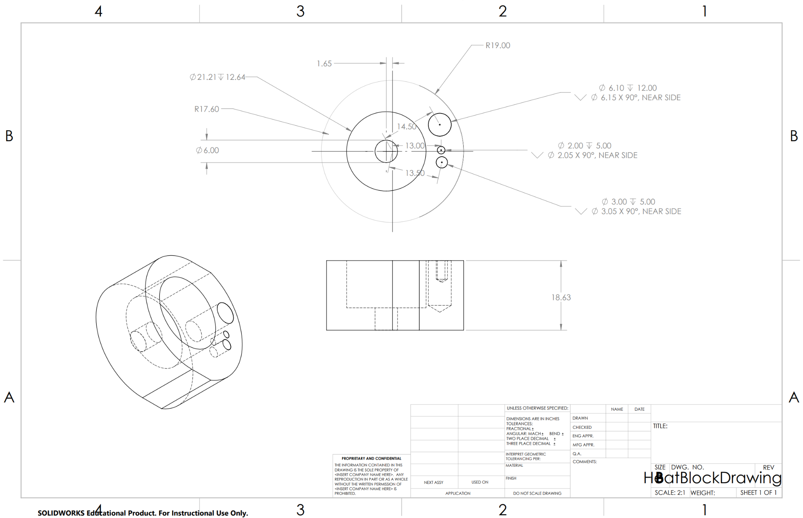

The flat edges are not necessary in the final design as they were originally meant for making the part more manufacturable. The barrel’s most important dimension is the press-fit hole for the black steel barrel. The dimensions for the three smaller holes follow the hole pattern spacing for the Ender-3 heat block very closely.

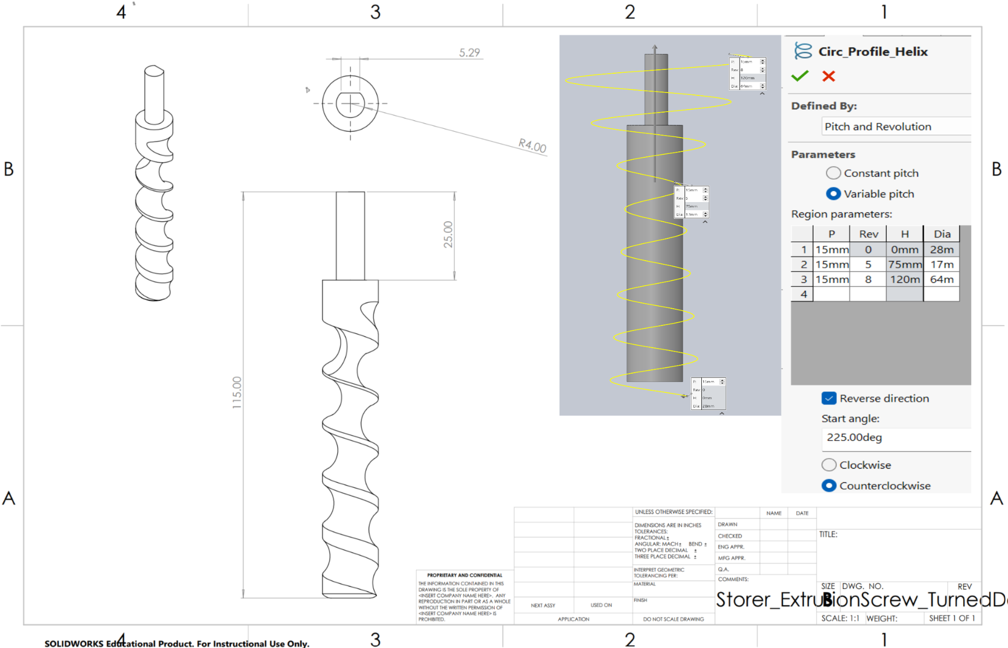

The screw’s geometry is based on a helix with three individual segments with their own pitch. The parameters for the helices are labeled on the preview with three little boxes. The parameters for the helices are also in the Circ_Profile_Helix table.

### Assembly drawings:

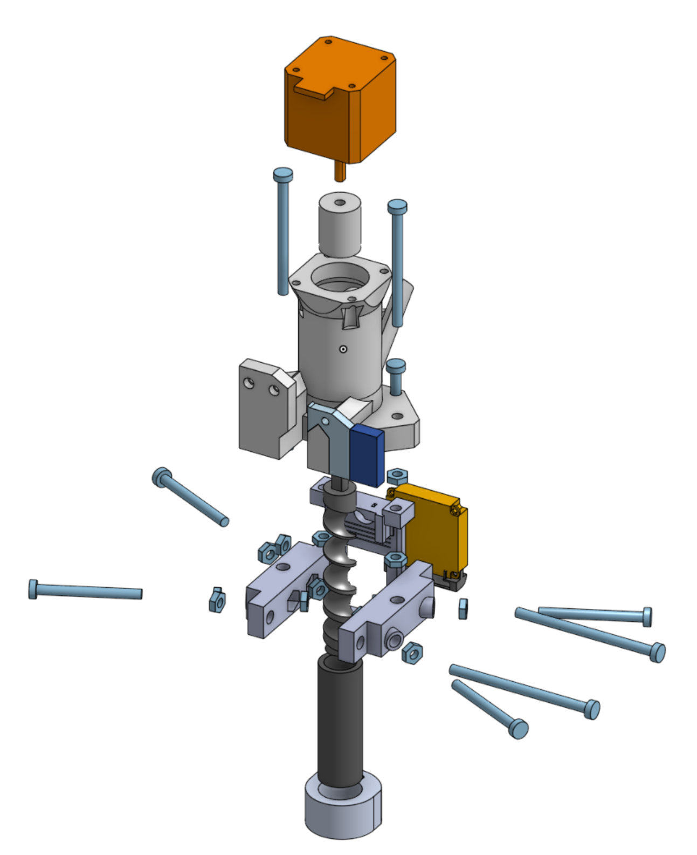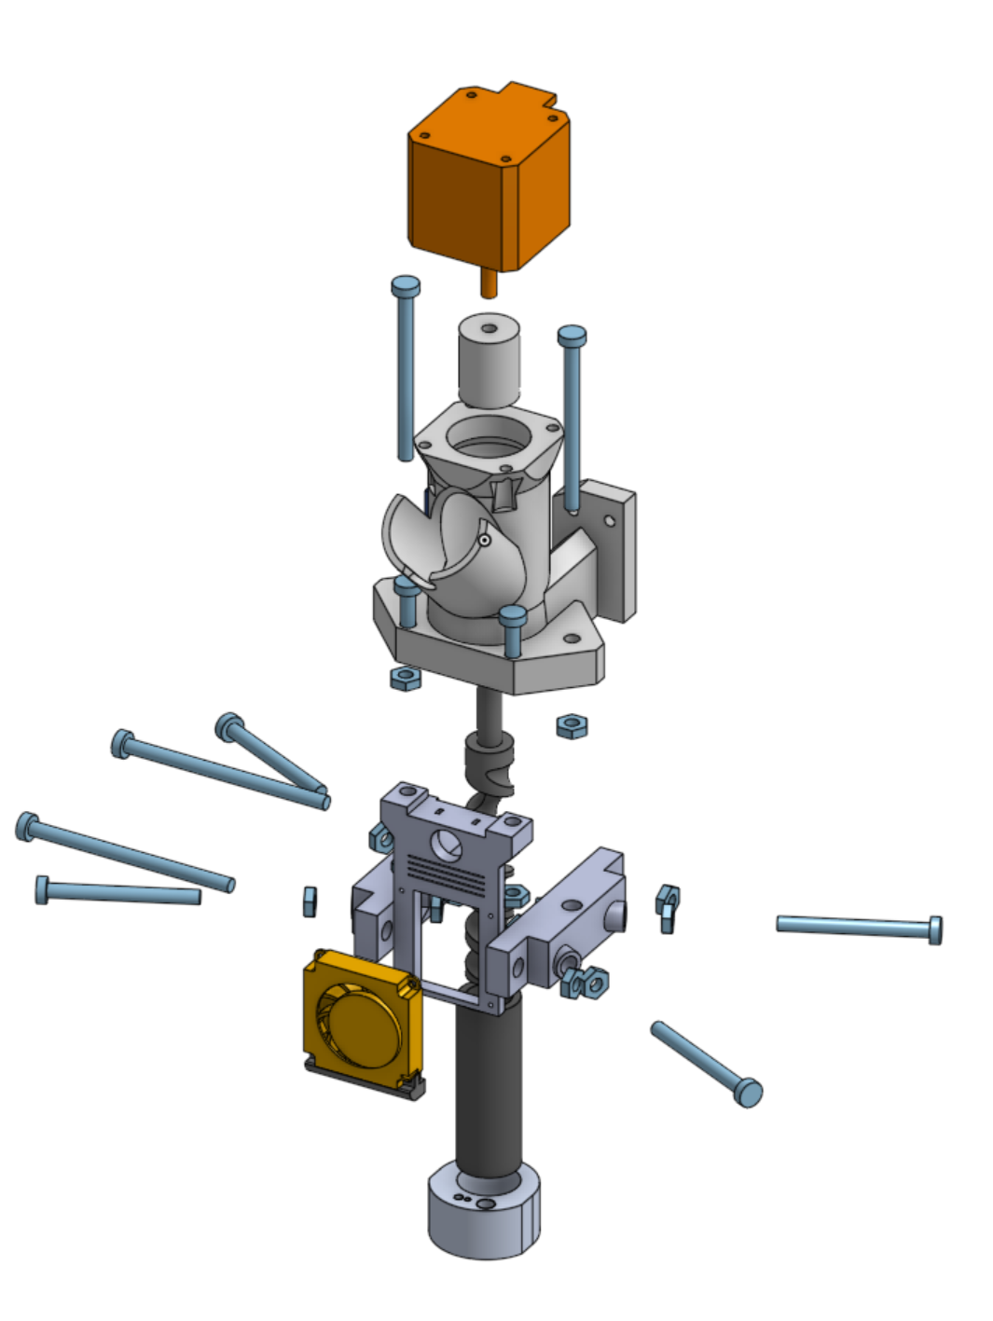

Two isometric views of the exploded model. The model and its parts can be found in the [OnShape Project Folder](https://cad.onshape.com/documents/24ec814f0aa771ba6b6b39f4/w/7c7ef0db674f39f2ce4eb73b/e/5d7ee87e87f6b38be38cb68a).

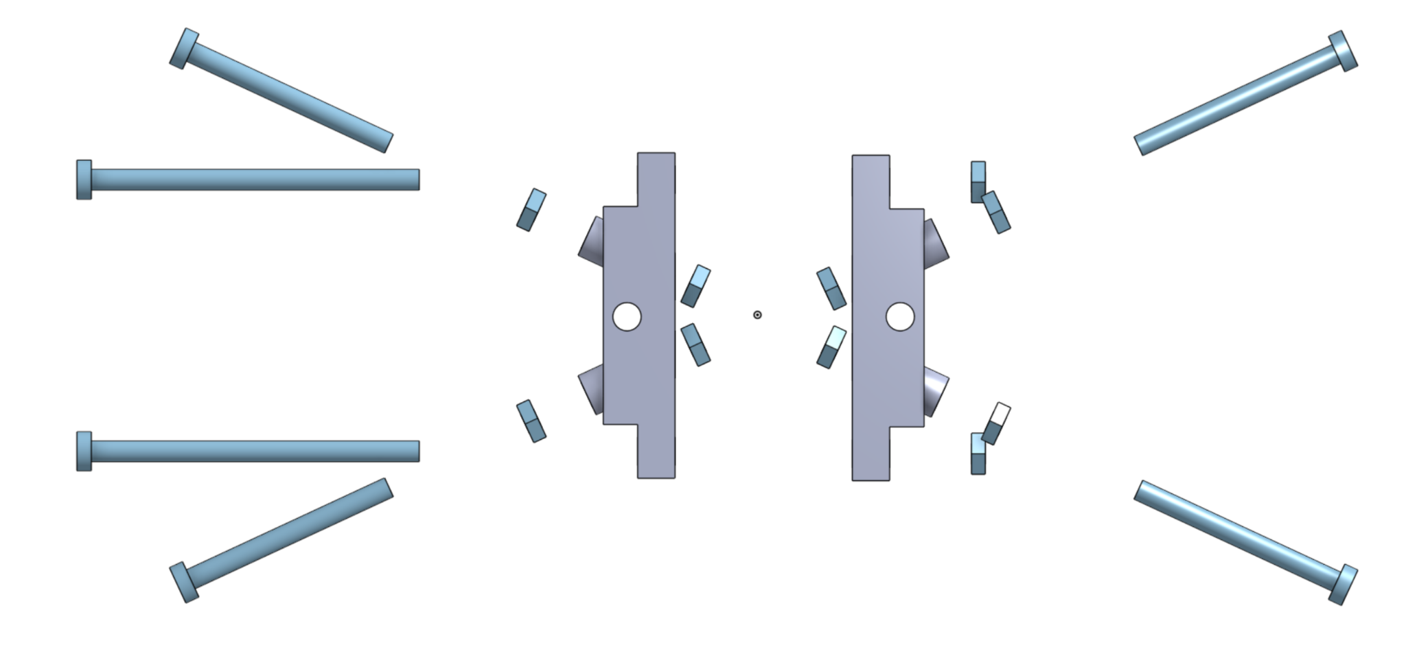

Isolated view of the barrel clamps and the bolts.

### Flow Charts for Control Systems

* We did not write our own control systems since the Ender 3 had built in control systems.

### Computer Code:

* We did not write code for the operation of the system, but did write code to calculate the dimensions of the screw. Those calculations are linked below.
  + [Computer Codes](https://drive.google.com/drive/folders/1YNIQtn1I4rh5Mel5AXPEYvcBOearV0iV?usp=drive_link)

### Electrical circuits:

* The electrical circuits included in the Ender 3 are shown below. Besides that, we did not design any electrical circuits as the ender had all the control systems required.
  + [Circuit Diagrams](https://drive.google.com/drive/folders/1OTnrep8ZZs7Rkf0-R4wiGuxogoQwrrbr?usp=drive_link)
  + The Ender Circuit provides all the control circuitry for powering the fans and sending signals to the stepper motors.
  + The stepper motor circuitry was used for our project specifically to reverse the direction of the stepper motor rotation. Such circuitry won’t be needed for future iterations of this design, as the screw will be designed correctly to extrude while spinning in the default Ender 3 “forward” direction.

## Appendix G

[Pellet 3D Printer Assembly Instructions](https://docs.google.com/document/d/1HU0jos_mn8zzjRmjtwaB9pEYKUADIomTM53ebHeet08/edit#heading=h.pcloj0m64ixs)